**Verilog code to implement 8 bit RCA**

**Design Code:**

module fa(input a,b,cin, output s,cout);

    assign s = a^b^cin;

    assign cout = a&&b || b&&cin || a&&cin;

endmodule

module rca(input [7:0] a, b, input cin, output cy, output [7:0] s);

wire [6:0] co;

fa f1(a[0],b[0],cin,s[0],co[0]);

fa f2(a[1],b[1],co[0],s[1],co[1]);

fa f3(a[2],b[2],co[1],s[2],co[2]);

fa f4(a[3],b[3],co[2],s[3],co[3]);

fa f5(a[4],b[4],co[3],s[4],co[4]);

fa f6(a[5],b[5],co[4],s[5],co[5]);

fa f7(a[6],b[6],co[5],s[6],co[6]);

fa f8(a[7],b[7],co[6],s[7],cy);

endmodule

**Test Bench:**

module tb;

    reg [7:0] a, b;

    reg cin;

    wire cy;

    wire [7:0] s;

    integer i;

    integer x;

    rca uut (a,b,cin,cy,s);

    initial begin

        repeat(10) begin

            x =0;

            a = $random;

            b = $random;

            cin = $random;

            i = a+b+cin;

            #1;

            if ({cy,s}!=i) x = x+1;

            else $display("input is %d,%d,%d , output is %d",a,b,cin,{cy,s});

            #10;

        end

    end

endmodule

**Simulation Result:**

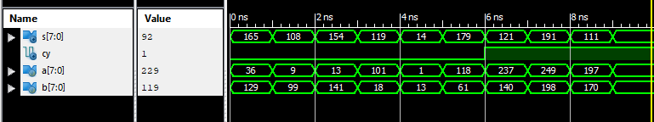

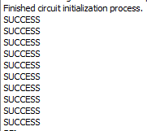

**RTL Diagram:**

